* We hold 15% of the data, and train two models on two data –
* 1. one w/o COVID pattern (x), and
* 2. other with COVID pattern (y))
* We then combine results of these models and try to predict values over next 15% data (c).
* The result is validated as 4ax + 5by = 9c.
* The values of a and b are then obtained by solving above equation.
* We solve to minimize “ (4a/9)x + (5b/9)y – c “.
* We can use genetic algorithms or other optimization methods to solve above problem.
* After identifying best a and b, we retrain the two models on full available datasets, and then combine their results with calculated a and b using, $\frac{(4ax + 5by)}{9}$.

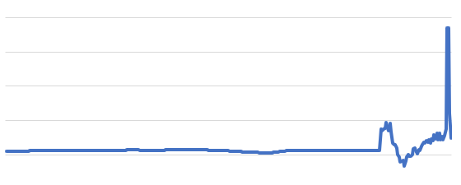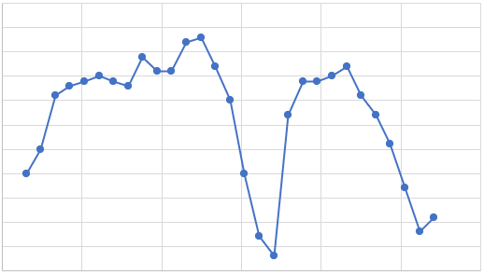

Note:

* α and β are parameters that weigh the contributions of both these trends.
* So, they can be set as ratio of their timelines they are covering and contributing.
* Since without COVID-19 is covering data from 1991-2019 (=336 months) and with COVID-19 data is covering from 1991-2020 (=420 months), so
* α can be 0.4444 and β can be 0.5555.

Weighted Average

α

β

Time-series Forecasting Model

Time-series Forecasting Model

Data with COVID-19 pattern

Data without COVID-19 pattern